SIMATS ENGINEERING
ASSESSMENT TOOL 2: Case Study

COURSE NAME: | Cloud Computing and  Big Data Analytics | COURSE CODE: | CSA1504

COURSE OUTCOME COVERED
CO3: Implement cloud-based solutions using cloud storage, web APIs, and platform services for real-world applications. (BL3)

Dave's Taxonomy: Precision (Level 3)  Question Count: 3 | Total Marks: 30

Code of Conduct
I M.VINAY(192311146) (Name / Reg No) certify that this submission is my original work and that I have adhered to the guidelines specified for this assessment.
I understand that any violation of academic integrity rules will result in disciplinary action. Signature of the student: M.VINAY

Assessment Tasks Case Study
- Case Study 1: Smart Retail Inventory Management System

A retail chain implements a cloud-based inventory system connected to store devices.Clients (POS systems and dashboards) communicate via APIs to centralized cloud services. Cloud storage stores product data, transaction logs, and analytics datasets. The system uses platform services for analytics and demand forecasting. Secure access is maintained through VPNs, firewalls, and API gateways. This solution integrates infrastructure, services, and web applications for efficient operations.

Case Study 2: Cloud-Based Document Collaboration System

An enterprise deploys a document collaboration tool similar to Google Docs. Users access the platform via browsers, enabling real-time editing and sharing. Documents are stored in distributed cloud storage with version control mechanisms. Web APIs enable synchronization across multiple clients and devices.
Network infrastructure ensures low latency and high availability globally. Security includes encryption, identity management, and access permissions for collaboration.

Case Study 3: Online Food Ordering Platform

A startup builds a cloud-based food ordering system accessible via web browsers and mobile clients.
Frontend clients interact with backend services through RESTful Web APIs hosted on a cloud platform.
Cloud storage is used to store menu images, invoices, and customer data securely. The infrastructure uses virtual machines and managed Kubernetes for scalability and reliability. Security is enforced

through authentication tokens, HTTPS, and role-based access control. The system demonstrates integration of clients, APIs, storage, and platform services in real time.

Case Study Rubric
Criteria | Weightage | Level 4 - Exemplary | Level 3 - Proficient | Level 2 - Developing | Level 1 - Beginning
Understanding of Case | 25% | Clearly  identifies all technical and business  requirements | Identifies most requirements | Basic understanding only | Poor understanding of case
Application of Concepts | 25% | Applies  suitable cloud concepts and tools effectively | Good application with minor issues | Partial application | Weak or incorrect application
Analysis | 20% | Strong analysis with clear trade-off  reasoning | Reasonable analysis | Limited analysis | Minimal analysis
Solution Design | 20% | Solution is feasible, practical, and well justified | Reasonable solution with minor gaps | Basic solution | Unclear solution
Clarity | 10% | Well-structured and easy to  follow | Mostly clear | Somewhat unclear | Poorly organized

SOLUTIONS:

Case Study 1: Smart Retail Inventory Management System
Scenario:
A retail chain implements a cloud-based inventory management system to monitor stock levels across multiple stores.
Main Components:
- Clients: POS systems and management dashboards.
- APIs: Connect store devices and clients to cloud services.
- Cloud Infrastructure: Provides computing and networking resources.
- Cloud Storage: Stores product information, transaction records, and analytics data.
- Platform Services: Used for data analytics and demand forecasting.
- Security: VPN, firewalls, and API gateways protect the system.
Working:
Store devices send inventory and sales information through APIs to centralized cloud services. The data is stored in cloud storage and analyzed using platform services. Demand forecasting helps the retailer predict future product requirements.
Tree Diagram:
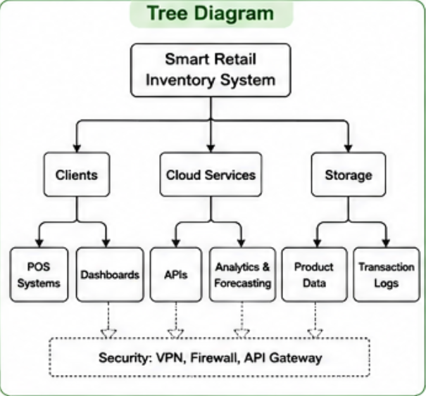
Architecture Diagram:
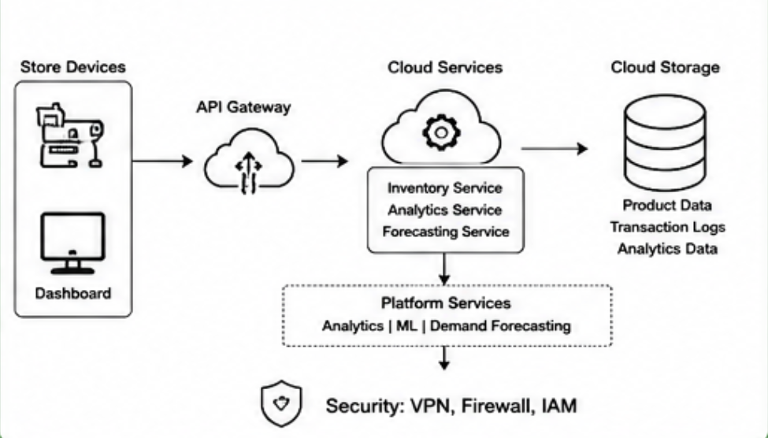
Benefits:
- Real-time inventory monitoring
- Improved demand forecasting
- Centralized data management
- Scalable cloud infrastructure
- Secure access to retail data

Case Study 2: Cloud-Based Document Collaboration System
Scenario:
An enterprise deploys a cloud-based document collaboration system similar to Google Docs. Users can create, edit, share, and manage documents through web browsers.
Main Components:
- Clients: Web browsers and multiple user devices.
- Web APIs: Synchronize documents between clients and cloud services.
- Cloud Storage: Stores documents and their versions.
- Version Control: Maintains previous document versions.
- Network Infrastructure: Provides low-latency and highly available access.
- Security: Encryption, identity management, and access permissions.
Working:
Users access documents through browsers. Changes made by one user are synchronized through Web APIs and made available to other authorized users in real time. Documents are stored in distributed cloud storage with version control.
Tree Diagram:
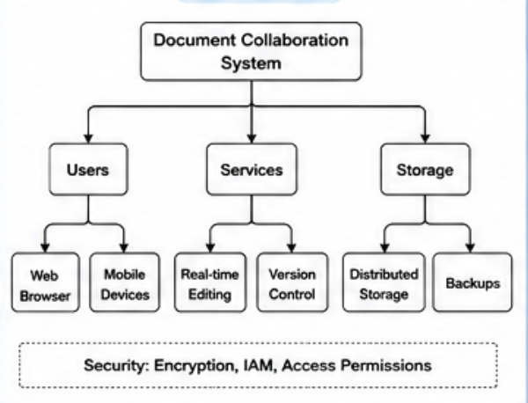
Architecture Diagram:

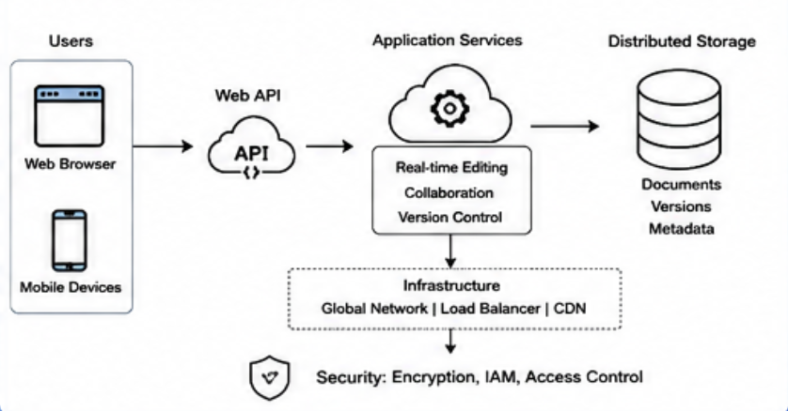
Benefits:
- Real-time collaboration
- Easy document sharing
- Automatic synchronization
- Version history
- Global accessibility
- Secure document management

Case Study 3: Online Food Ordering Platform
Scenario:
A startup develops a cloud-based food ordering platform that allows customers to order food using websites and mobile applications.
Main Components:
- Clients: Web browsers and mobile applications.
- RESTful Web APIs: Connect frontend clients with backend services.
- Cloud Platform: Hosts backend applications and services.
- Cloud Storage: Stores menu images, invoices, and customer information.
- Virtual Machines: Provide computing resources.
- Managed Kubernetes: Supports scalability and reliable application deployment.
- Security: Authentication tokens, HTTPS, and role-based access control.
Working:
Customers use the web or mobile application to browse menus and place orders. The frontend communicates with backend cloud services through RESTful APIs. Customer and order information is securely stored in cloud storage. Virtual machines and Kubernetes allow the platform to handle increasing numbers of users and orders.
Tree Diagram:
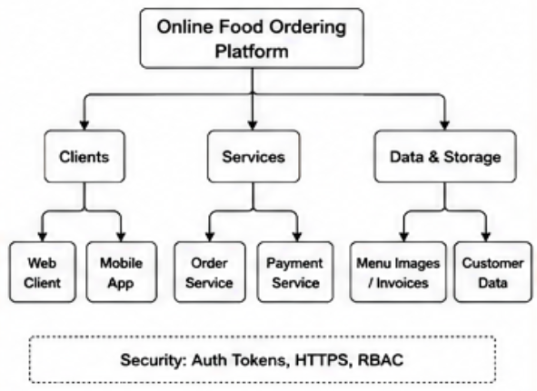
Architecture Diagram:
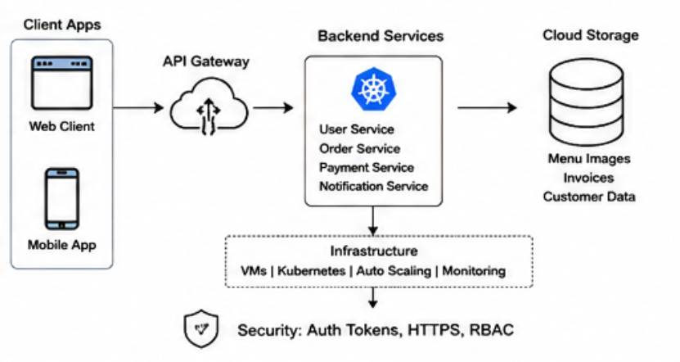
Benefits:
- Supports web and mobile clients
- Scalable infrastructure
- Reliable food ordering services
- Secure customer data
- Real-time API communication
- High availability and performance

